Cartridge Material System Operation and Maintenance Manual

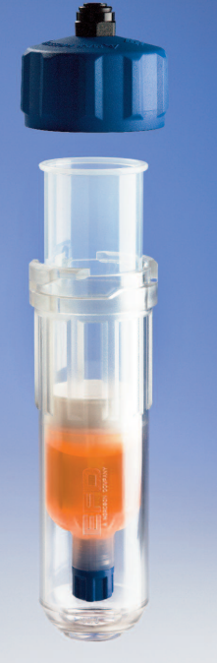Massivit 1800

MASSIVit: http://massivit3d.com

Customer support: [support@massivit.com](mailto:support@massivit.com)

Rev: A Nov 2018

Safety Instructions

Pressurized tubing can be very dangerous. Tubing whose integrity is compromised due to wear, damage, or misuse can develop a leak, spraying materials at high pressure. This spray can enter the eyes, or cover the skin, or cause other serious bodily injury, fire or property damage. Before pressurizing any system, examine all tubing for cuts, wear, bulges and leaks. If any of these conditions exist, replace the tubing immediately with approved tubing. Do not try to repair a damaged tube.

* BE SURE all tubing connections to the system are properly secured.
* BE SURE that the material to be dispensed is compatible with the tubing and dispenser system.

Always wear appropriate protective equipment such as glasses, gloves, and clothing suitable for your dispensing application.

* Do not exceed maximum operating pressure of 6 bar (87psi).
* Do not heat syringe barrels or cartridges to a temperature greater than 100°F (38°C).
* Do not clean components with strong solvents (e.g. MEK, Acetone, THF).
* Clean the cartridge retainer systems with mild detergents only.

Table of Contents

1 Introduction 4

2 Setup Machine 5

3 Load Material 7

3.1 Prepare printer 7

3.2 Install the cartridge in the retainer 8

3.3 Install the retainer on the machine 9

3.4 Air bleeding 11

4 Replace Cartridge 13

4.1 Prepare printer 13

4.2 Remove cartridge 13

5 Maintenance 14

6 P/N LIST-x 15

# Introduction

The machine is a customized version of the Massivit 1800. The machine has two heads. The left head is connected to the bucket feed pump, as described in the user manual. The right head is customized and its dispenser is fed by cartridges. This guide describes the replacement, maintenance and safety instructions specific to the cartridge system.

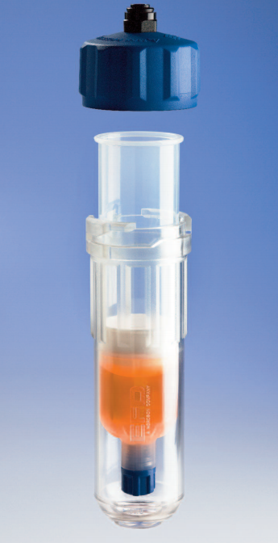

**Retainer**

**Cartridge (consumable)**

**Retainer Cap**

# Setup Machine

1. Set the air pressure to 3 bar, suitable for DM100 viscosity. For higher viscosity, consider increasing the retainer pressure slightly in order to achieve a dispenser pressure of ~1bar during printing (do not exceed 6 bar retainer pressure).

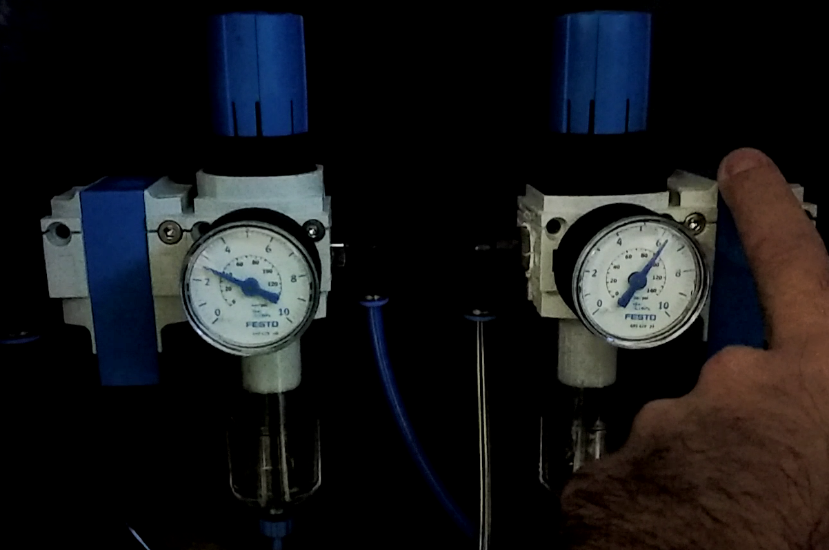

**Left pressure regulator (for retainer). Set to 3 bar**

**Right pressure regulator (main pressure). Set to 6 bar**

1. Set the cartridge quantity indicator. From the main menu, select **Material 🡪Syringe.**

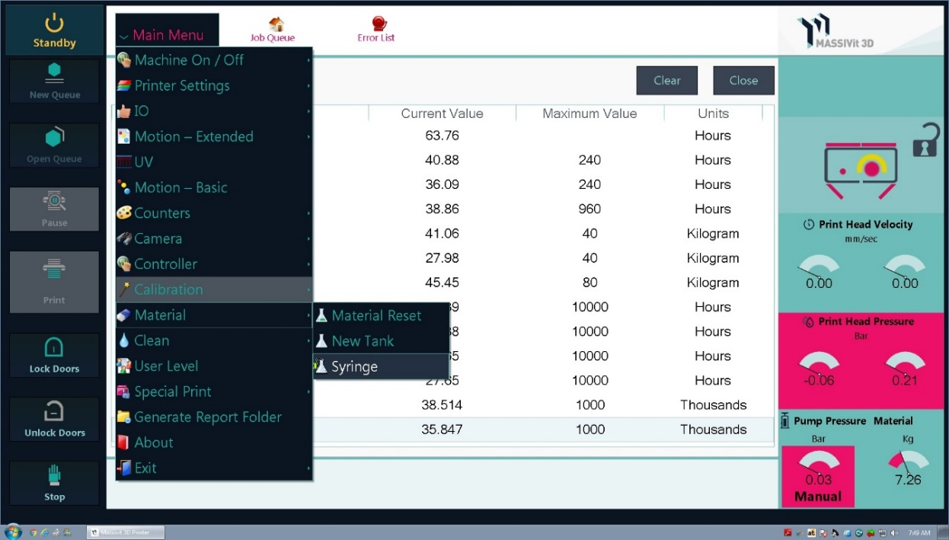

1. Enter volume quantities for the syringe:

**Syringe total volume -** the total volume of the cartridge when full.

**Syringe current volume** **–** the actual quantity in the cartridge, update in real-time. Press **Reset** after filling the syringe, to reset this reading.

**Syringe alarm volume –** set this to the value at which the printer will alarm/stop the printing when.

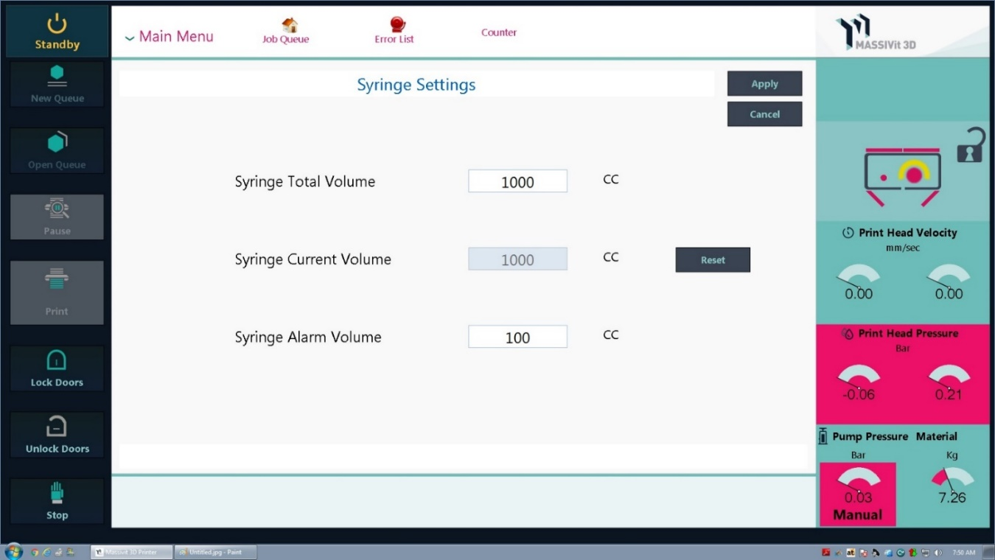

**Note**: if material is exhausted in the cartridge, the head pressure will drop to zero. This is another indication of material done.

# Load Material

## Prepare printer

1. Switch the machine ON.
2. Select **Machine On,** and wait for the status indicator to show **On**.

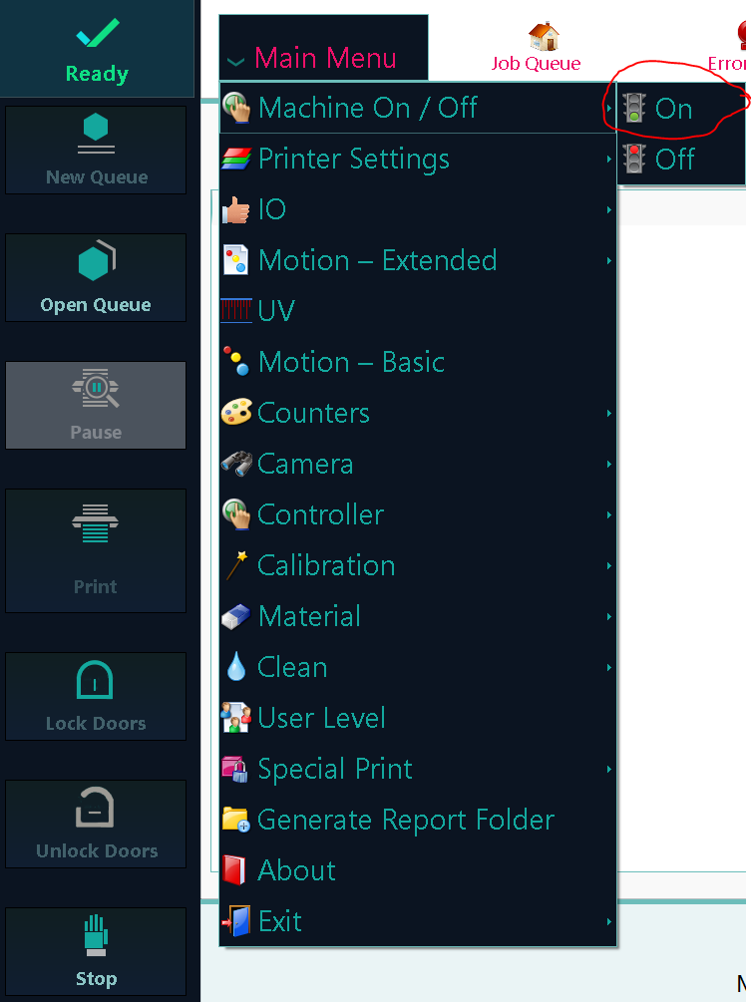

1. From the main menu, select **Motion-Extended 🡪 Virtual Global Z**.



1. Set the Absolute position to 1200 mm, then press **Move.** Wait for it to complete.

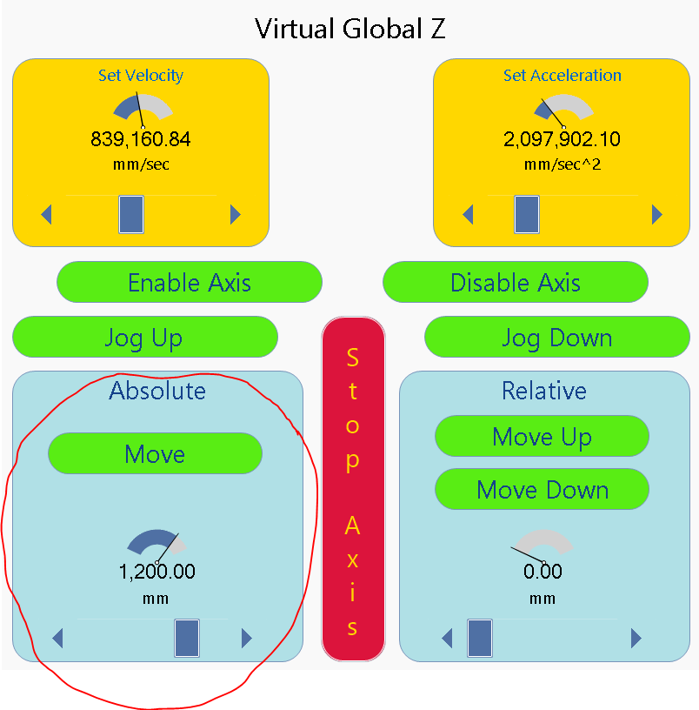

1. Press the emergency red button to ensure there is no motor movement while inside the machine.

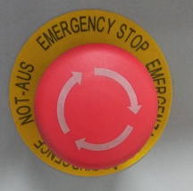

1. Place a maintenance mat on the print table to avoid glass damage.

## Install the cartridge in the retainer

**Note**: This activity is performed on a work bench outside the machine.

1. Fill the cartridge with printing material. Leave a gap of at least 0.5 inches (12.7mm) from the top of the piston to the top of the cartridge, to allow for the cartridge back cap.

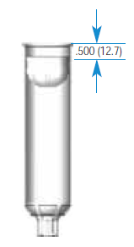

1. Insert the new cartridge into the retainer.
2. Place the retainer cap on the retainer body.
3. Twist the retainer cap clockwise until it locks in place and the arrow below the lock icon on the cap aligns with the arrow on the retainer body.

**Note**: It is very important to ensure the retainer cap is properly locked onto the retainer body, as both are later pressurized. Improper closure may result in the retainer cap disengaging from the body upon application of air pressure.

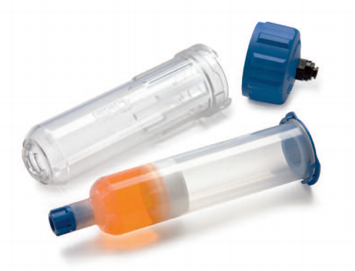 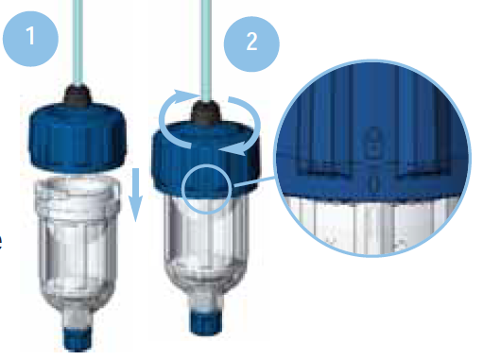

## Install the retainer on the machine

1. After making sure the cap is closed, take the retainer and place it on the two holders on the right bridge.

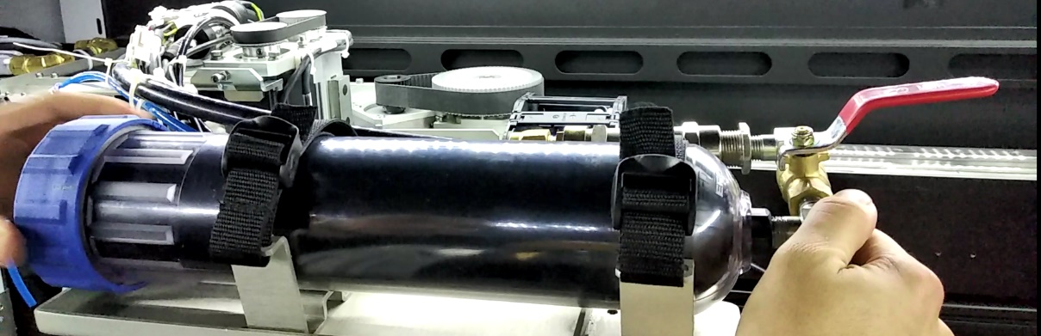

1. Remove the small blue cap from the cartridge barrel.

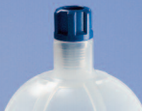

1. Connect the cartridge thread to the material fitting by twisting the retainer clockwise.

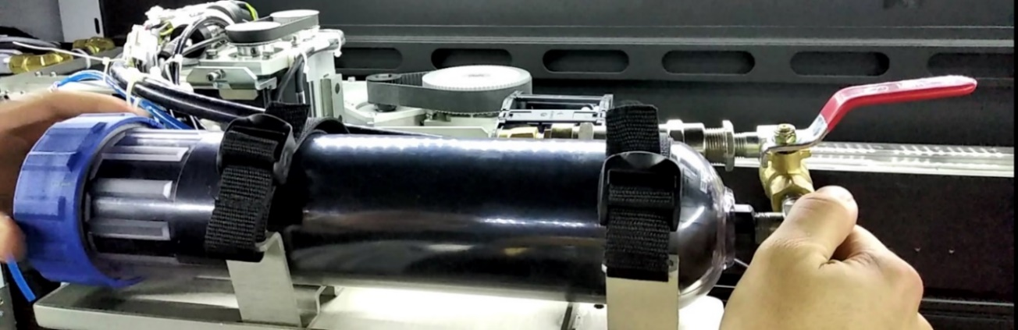

1. Insert the air pressure pipe into the air fitting by pushing firmly into the quick fit coupling.

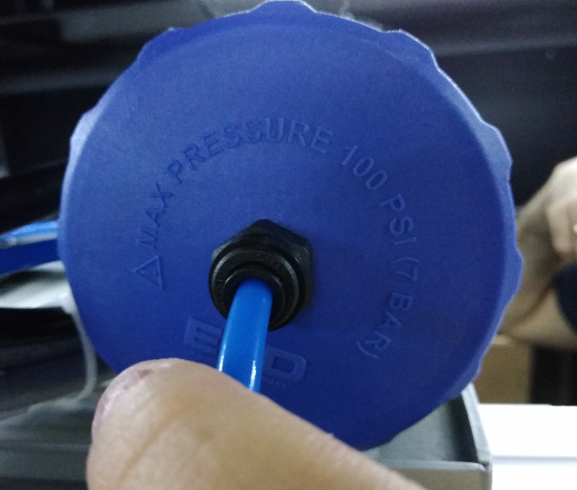

1. Secure the retainer in place using the safety straps.

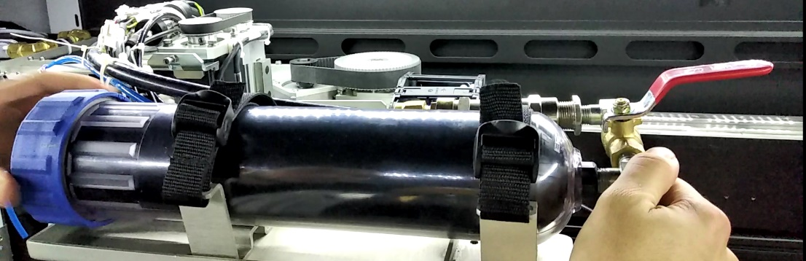

1. Open the material valve.

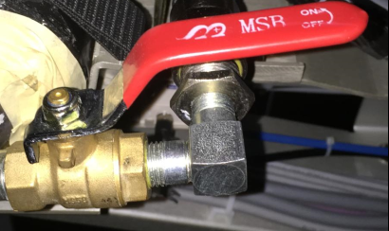

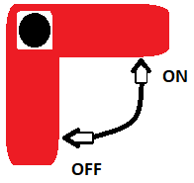

1. Open the air valve.

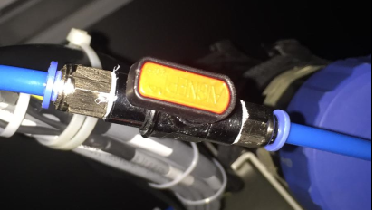

## Air bleeding

When replacing the cartridge, some air is trapped in the material pipes. In order to perform quality printing, it is recommended to drain the material in the pipes (approximately 150gr) through the dispenser nozzle, until material coming out no longer contains air bubbles.

1. Place a suitable container under the dispenser tip.
2. From the main menu, select **Basic Motion 🡪Printing head 1**.

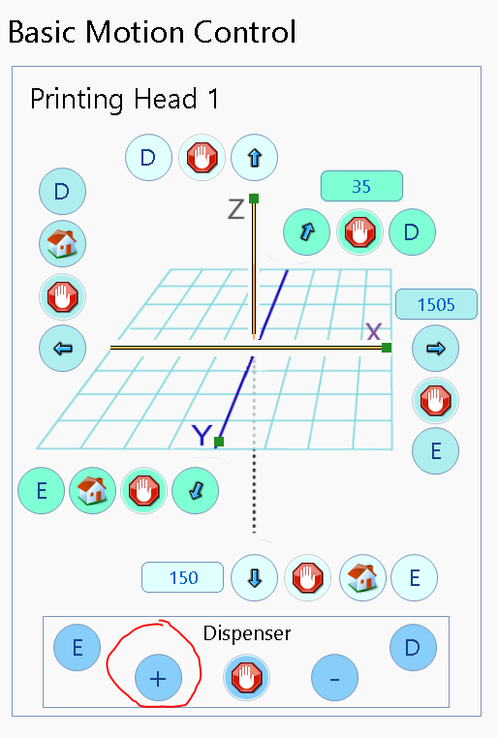

1. Check the material coming out of the dispenser tip, and wait until the new material is flowing constantly out of the dispenser, and until there are no more air bubbles (this should happen after approximately 150 grams of material have been dispensed).
2. From the main menu, select **Basic Motion 🡪Printing head 1🡪 Dispenser STOP.**
3. If the material type was switched, from the main menu, select **Calibration 🡪 Material Adjust**, to calibrate the specific gravity of the material, before starting to print.

The machine is now ready to print.

# Replace Cartridge

## Prepare printer

Repeat section ‎3.1

## Remove cartridge

**Note**: follow these instructions closely, paying attention to the safety aspects listed below.

1. Close the material valve.

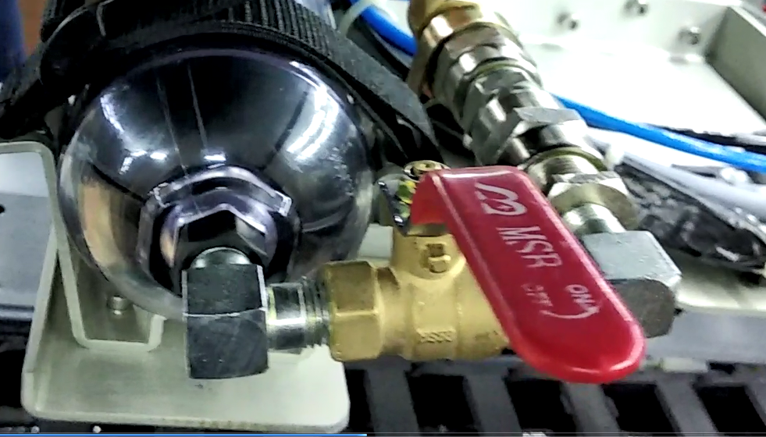

1. Close the air valve and wait until all the air is exhausted from the pipes and retainer.

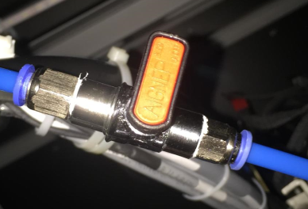

1. Disconnect the air pipe by pressing on the plug and pull the pipe out (don’t pull hard).
2. Release the strips that hold the retainer in place.
3. Holding the material pipe valve, twist the retainer counterclockwise to disconnect it from the material fitting.
4. Remove the retainer and cartridge from the machine.
5. Connect the end cap to stop material leaking from the end of the fitting pipe.

# Maintenance

* Clean the retainer after every use to avoid material curing and clogging the system.
* Clean system with a mild cleaning solution; do not use a strong solvent.
* Inspect the retainer cap O-ring periodically for wear. If its damaged or missing, replace it.
* Look for air/material leaks, search for material on the material pipes or ear air leak.

# P/N LIST-x

| **Picture** | **Catalog number** | **Description** | **Qty** | **Size** |
| --- | --- | --- | --- | --- |
|  | P/N 7013899  Nordson | Retainer system  Inc.  Cartridge, Buna outlet cap, end cap | 1 | 32 oz |
|  | P/N 7014091  Nordson | Cartridge | 1 | 32 oz |
|  | P/N 7012421  Nordson | Piston wiper | 1 | 32 oz |
|  | P/N 7026917  Nordson | Retainer cap O-ring | 1 | 32 oz |
|  | P/N 7012428  Nordson | End cap | 1 | - |
|  | PCM-00010 Massivit | Air pressure regulator | 1 | - |
|  | FTG-00193  Massivit | ¼-6 mm  ELBOW 1/2" TO 6MM QUICK CON  PL6-04 | 1 | ¼”-6 mm |
|  | FTG-00103  Massivit | ELBOW 1/2" TO 12MM QUICK CON | 1 | 1/4”-12 mm |
|  | FTG-00043  Massivit | FITTING, T, UNION, D=12 | 1 | 12 mm |
|  | TUB-00012 Black  Massivit | TUBE POLYURETHANE 12X8 BLACK | 1 | D=12mm  L= 36 cm |
|  | TUB-00120 Blue  Massivit | TUBE, NYLON, 6X4, BLUE | 1 | D=6  L=10m |
|  | Screw  Universal | M4-45 | 2 | - |
|  | I66002  Yeruham automation |  | 1 | D=6 |
|  | JPC06-1/8  Yeruham automation |  | 2 | 1/8”- 6mm |
|  | 90M-0404-NPT  Lia Hydraulics | Elbow ¼” M-M | 2 | - |
|  | 7973003025  Lia Hydraulics | Valve 2 way  ¼” F-F | 1 | ¼” |
|  | PF-04BSP  Lia Hydraulics | Cap ¼” F | 1 | - |
|  | B-0804-NPT  Lia Hydraulics | ¼”-1/2” F-M | 1 | - |
|  | MU-0808-BSP  Lia Hydraulics | 1/2”-1/2” M-M | 1 |  |
|  | MUFA-08-BSP  Lia Hydraulics | ½” F-F | 2+ | - |
|  | FTG-00062  Massivit | Stiffener sleeve, 14, 12, brass | 1 | 12-14 MM |
|  | FTG-00023  Massivit | MALE ADAPTOR UNION, STRAIGHT, 14MM TO 1/2 NPT | 1 | ½”-14 MM |
|  | Universal | 16mm pipe standoff clamp |  | - |
|  | TUB-00114  Massivit | 14mm pipe | 1 | 0.5 m |
|  | Universal | Tie straps | 2 |  |